HTML Head Element

📘 Definition
# Source: AI Source: Provided by: [Data Path: Persons Table -> ID Column: 1, Name_En Column: Motasem Essam] -> From: [ChatGPT] on [5/6/2026]
The HTML <head> element is a part of an HTML document that contains information about the webpage, not the visible content.
It helps the browser understand how to display and handle the page.

🧠 What goes inside the <head>?
# Source: AI Source: Provided by: [Data Path: Persons Table -> ID Column: 1, Name_En Column: Motasem Essam] -> From: [ChatGPT] on [5/6/2026]
The <head> section can include:
- Title of the page (shown in the browser tab)
- Meta information (like description, keywords, character set)
- Links to styles (CSS)
- Scripts (JavaScript)
- Icons (favicon)

💻 Example of <head> element

Full Example
# Source: AI Source: Provided by: [Data Path: Persons Table -> ID Column: 1, Name_En Column: Motasem Essam] -> From: [ChatGPT] on [5/6/2026]
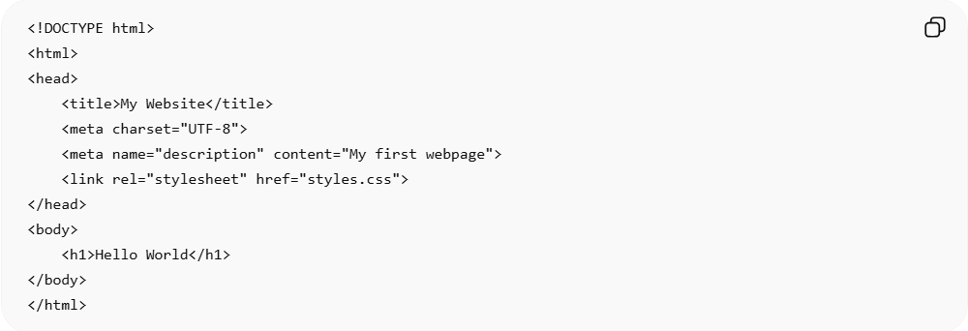
<!DOCTYPE html>
<html>
<head>
<title>My Website</title>
<meta charset="UTF-8">
<meta name="description" content="My first webpage">
<link rel="stylesheet" href="styles.css">
</head>
<body>
<h1>Hello World</h1>
</body>
</html>

Real Example
# Source: ScreenShot Source: Provided by: [Persons Table -> ID Column: 1, Name_En Column: Motasem Essam] -> Tool: [Automation Table -> ID Column: 16, Name_En Column: Screen Capture] -> From [Operating System: Windows] on [5/6/2026]
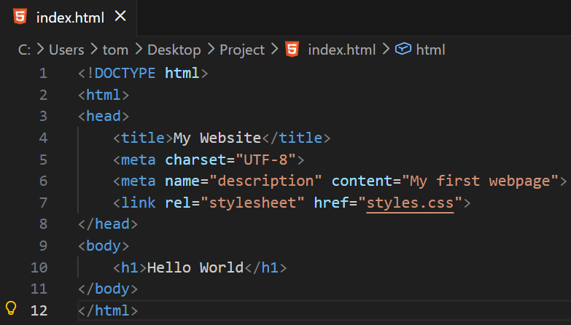
<!DOCTYPE html>
<html>
<head>
<title>My Website</title>
<meta charset="UTF-8">
<meta name="description" content="My first webpage">
<link rel="stylesheet" href="styles.css">
</head>
<body>
<h1>Hello World</h1>
</body>
</html>
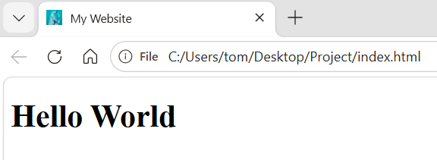

HTML <head> Elements
# Source: AI Source: Provided by: [Data Path: Persons Table -> ID Column: 1, Name_En Column: Motasem Essam] -> From: [ChatGPT] on [5/6/2026]
Here are the main elements inside the <head> with short descriptions:
🔹 <title> Element
Defines the title of the webpage shown in the browser tab.
🔹 <style> Element
Used to add internal CSS styles for designing the webpage.
🔹 <link> Element
Connects the HTML document to external files like CSS stylesheets or icons.
🔹 <script> Element
Used to include JavaScript code for adding interactivity to the webpage.
🔹 <base> Element
Specifies a base URL for all relative links in the page.
🔹 <meta> Element
Provides metadata about the webpage (such as description, character set, and SEO info).

⚙️ How it works
# Source: AI Source: Provided by: [Data Path: Persons Table -> ID Column: 1, Name_En Column: Motasem Essam] -> From: [ChatGPT] on [5/6/2026]
- The browser reads the <head> first
- It uses the information to:
  - Set the page title
  - Load styles and scripts
  - Improve SEO (search engine optimization)

❗ Important note
# Source: AI Source: Provided by: [Data Path: Persons Table -> ID Column: 1, Name_En Column: Motasem Essam] -> From: [ChatGPT] on [5/6/2026]
- Content inside <head> is not displayed on the webpage
- It works behind the scenes

🚀 In short:
# Source: AI Source: Provided by: [Data Path: Persons Table -> ID Column: 1, Name_En Column: Motasem Essam] -> From: [ChatGPT] on [5/6/2026]
The HTML <head> element stores important information about a webpage that helps the browser display it correctly, but it is not visible to users.

